HARAM FATIMA
26K-3122
Post lab task
Question1
#include<stdio.h>
int main() {
float percentage;
int F_income;
printf("Enter your marks Percentage:");
scanf("%f",&percentage);
printf("Enter your Family income:");
scanf("%d",&F_income);
if(percentage>=80||F_income<50000) {
printf("Univesity offer you a SCHOARSHIP");
}else {
printf("University doesnot offeer you A SCHOARSHIP");
}
return 0;
}
output
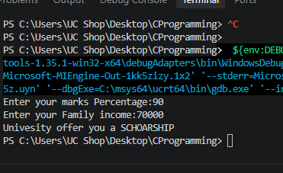
Question2:
#include<stdio.h>
int main() {
int Late_days;
printf("Enter number late Days:");
scanf("%d",&Late_days);
if(Late_days==0) {
printf("NO fine");
}
else{
if(Late_days>=1 &&Late_days<=5) {
printf("Fine:RS.50");
}else if(Late_days>=6 && Late_days<=10) {
printf("Fine:Rs.100");
}else{
printf("Fine:RS.200");
}
}
return 0;
}
Output
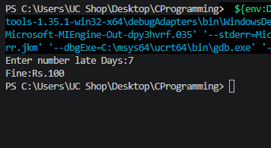
Question3;
#include<stdio.h>
int main() {
char name[50];
char ch;
printf("Enter full name:");
fgets(name,50,stdin);

printf("Enter a single character:");
scanf(" %c",&ch);
printf(" using put my output is\n");
puts(name);
printf("Character=%c",ch);
printf("fgets take full line output including spaces");
return 0;
}
Output
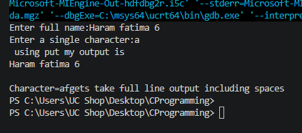
Question4
#include<stdio.h>
int main() {
float length,width;
printf("Enter length of Rectangle:");
scanf("%f",&length);
printf("Enter Width of Rectangle:");
scanf("%f",&width);
float Area;
Area=length*width;
float Peri_meter;
Peri_meter=2*(length+width);
printf("Area of Rectangle=%fcm\n",Area);
printf("Perimeter of Rectangle=%fcm\n",Peri_meter);
return 0;
}

Output:
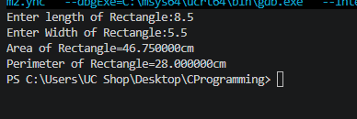

Question5
#include<stdio.h>
int main() {
int integer;
printf("Enter an integer:");
scanf("%d",&integer);
printf("Square=%d\n",integer*integer);
printf("Cube=%d\n",integer*integer*integer);
return 0;
}

Output;
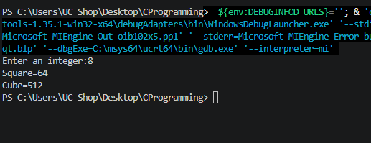
Question6;
#include<stdio.h>
int main() {
float C;
printf("Enter a temperature in celsius:");
scanf("%f",&C);
printf("Fahrenheit temperature=%2f F",(C*1.8)+32);
return 0;
}

Output:
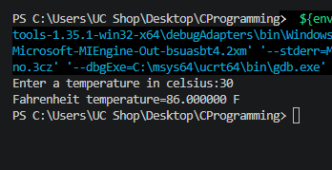
Question7
#include<stdio.h>
int main() {
float num1,num2,num3;
printf("Enter a num1: ");
scanf("%f",&num1);
printf("Enter a num2: ");
scanf("%f",&num2);
printf("Enter a num3: ");
scanf("%f",&num3);
float Average;
Average=((num1+num2+num3)/3);
printf("\nAverage=%.2f",Average);
return 0;
}

Output
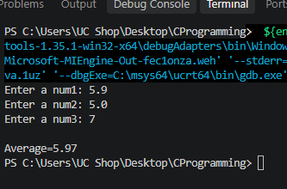
Question8
#include<stdio.h>
int main() {
float marks;
printf("Enter Student_marks:");
scanf("%f",&marks);
if(marks>=50) {
printf("Pass");
}else{
printf("FaiL");
}
return 0;
}

Output;
